**INSTALLING R AND BASIC OPERATIONS**

1. **INSTALLING R SOFTWARE**

**1. To install R, go to cran.r-project.org**



## 2. Choose for Download R for Windows

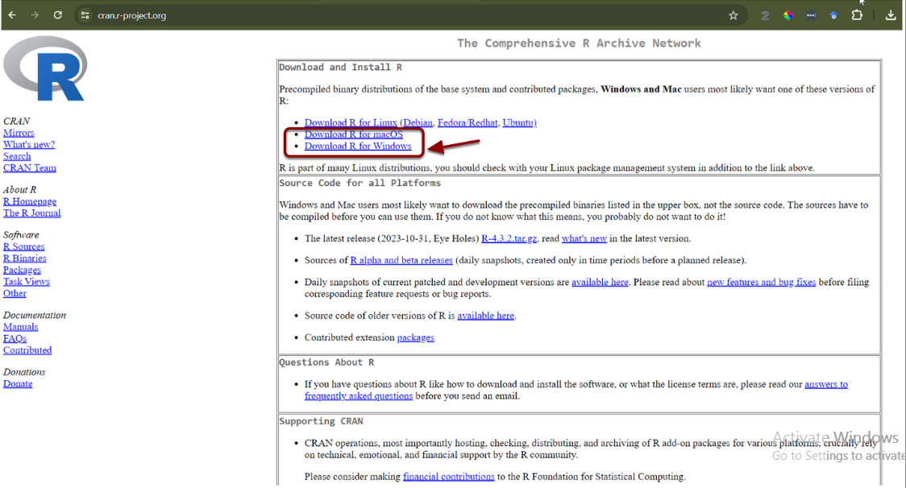

## 3. Install R Click on install R for the first time.

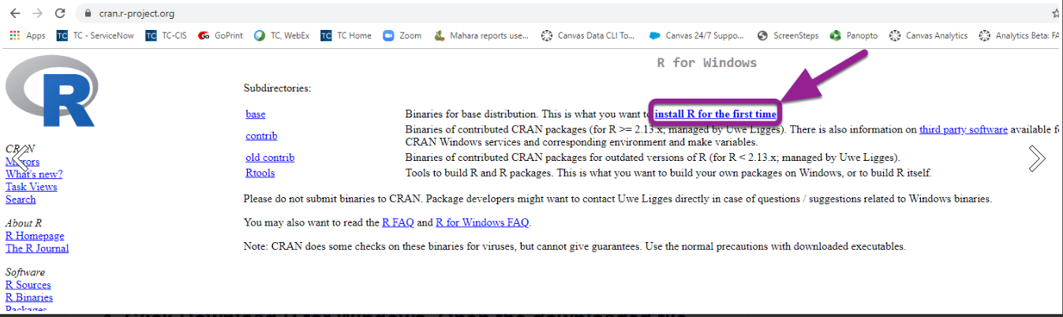

## 4. Click Download R for Windows. Open the downloaded file.

## 

## 5. Select the language. Then click OK.

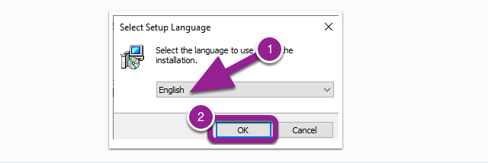

## 6. Click Next

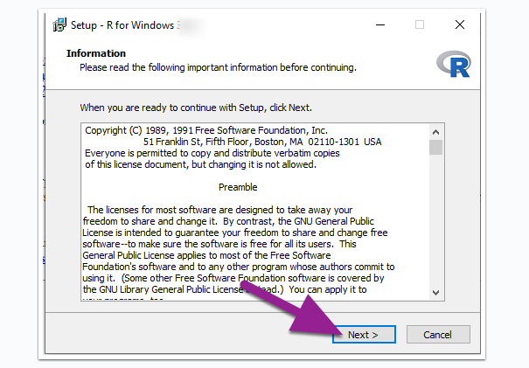

## 7. Select the Directory where the R dependencies should be located.

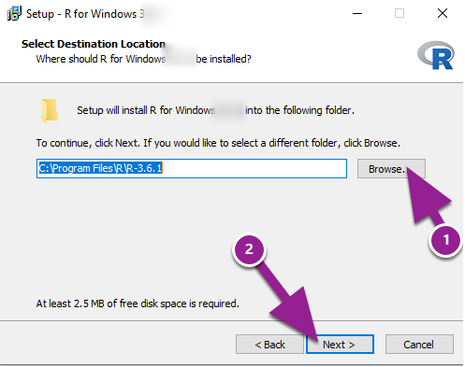

## 8. Choose the installation type.

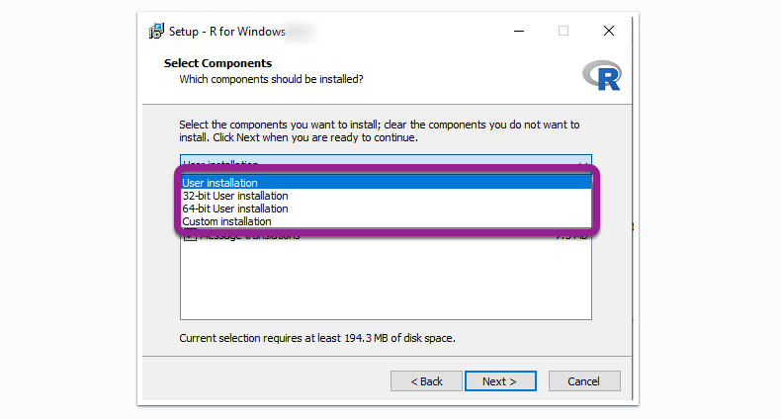

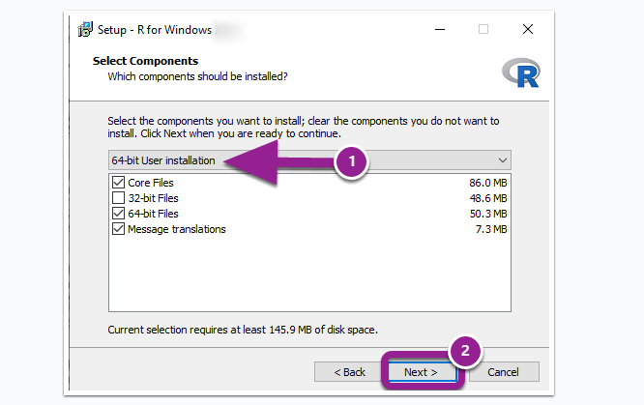

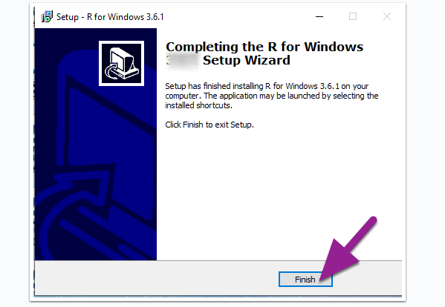

1. **INSTALLING R PACKAGE**

Installing ggplot2 package

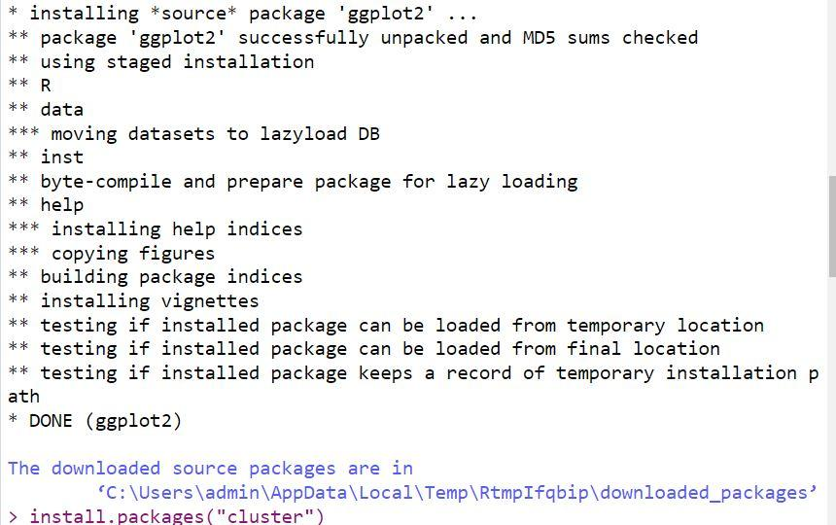

1. **R-BASIC OPERATIONS**

cat("\n1. VARIABLES & DATA TYPES \n")

num_var <- 10 # Numeric (double)

int_var <- 10L # Integer

char_var <- "Hello" # Character string

bool_var <- TRUE # Logical

complex_var <- 2 + 3i # Complex number

cat("Numeric:", num_var, "\n")

cat("Integer:", int_var, "\n")

cat("Character:", char_var, "\n")

cat("Logical:", bool_var, "\n")

cat("Complex:", complex_var, "\n")

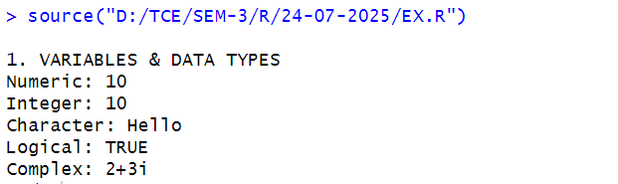

cat("\n2. DATA FRAMES n")

df <- data.frame(Name=c("Alice", "Bob", "Charlie"),

Age=c(25, 30, 35),

Score=c(85, 90, 95))

print(df)

cat("Access Age column:", df$Age, "\n");

